### 26th January 2017

### YOKOHAMA Celebrates “ADVAN” 40th Anniversary with New Logomark

Tokyo – The Yokohama Rubber Co., Ltd., has created a new logomark to celebrate the 40th anniversary of its global flagship “ADVAN” tyre brand. The new logomark will be used throughout 2018, starting in January, as YOKOHAMA expresses its gratitude to the many people in Japan and abroad who have helped make “ADVAN” a hit brand that has been loved for over 40 years.

“ADVAN” was born in 1978 as a tyre brand that pursues the “ultimate driving” experience. The brand’s initial offering, the “ADVAN HF”, was the first sports radial tyre to be introduced in Japan. Subsequent additions to the brand line-up have included many innovative hit products, such as 1981’s “ADVAN HF Type D.” The “ADVAN” brand’s use in motor sports in Japan and abroad has contributed greatly to raising awareness of the YOKOHAMA. Since 2005, YOKOHAMA’s global strategy has positioned the “ADVAN” brand as the company’s global flagship brand. “ADVAN” tyres’ technical excellence has won approval for its use on many of the world’s leading premium cars, contributing to its global growth as a brand symbolic of the high performance and quality of YOKOHAMA tyres.

Today, the “ADVAN” brand includes a diverse range of tyres for use on a wide variety of automobile classes, from high-performance premium cars to sports cars, luxury sedans, SUVs, and compacts. “ADVAN” tyres also come equipped as original equipment on many models from the world’s leading carmakers, including Porsche, Mercedes-Benz, Audi and other overseas makers as well as Japanese makers. In addition, YOKOHAMA has been supporting motor sports around the world by supplying its “ADVAN” racing tyres to teams in a wide variety of race types. For example, “ADVAN” has been the official tyre of the FIA World Touring Car Championship (WTCC) for 12 consecutive years since 2006 and became the official tyre of the Japanese SUPER FORMULA Championship series in 2016.

The 40th anniversary logomark uses a bold brush stroke to express the high performance and power that “ADVAN” tyres deliver to drivers on normal city streets and winding roads as well as to drivers in the top-category motor races.

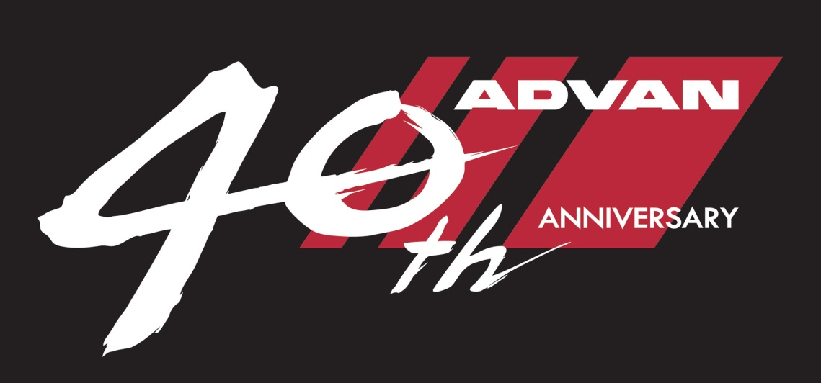

*“ADVAN” 40th anniversary logomark*